1.
public class Ques1 {
public static void main(String[] args) {
String s = "Hello World";
System.out.println("Old string " + s);
s = s.replace("Hello", "Welcome");
System.out.println("new string " + s);
}
}

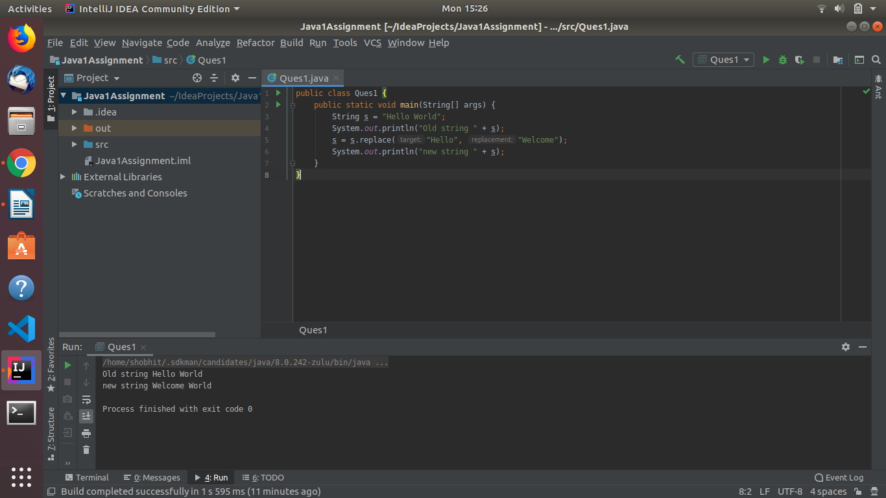

2.
public class Ques2 {
public static void main(String[] args) {
String input = "Welcome to Java Session Session Session";
String[] words = input.split(" ");
int wrc = 1;
for (int i = 0; i < words.length; i++) {
for (int j = i + 1; j < words.length; j++) {
if (words[i].equals(words[j])) {
wrc = wrc + 1;
words[j] = "0";
}
}
if (words[i] != "0")
System.out.println(words[i] + "--" + wrc);
wrc = 1;
}
}
}

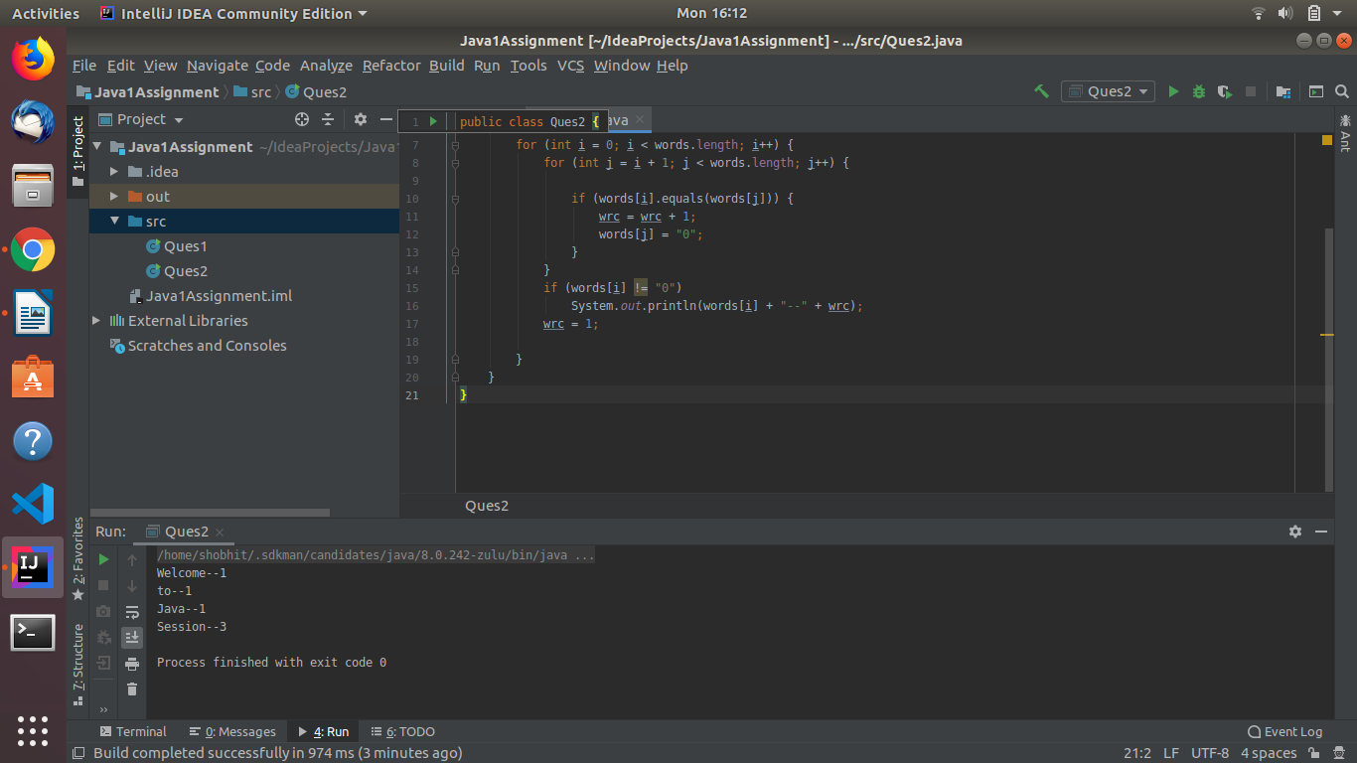
3.
class Ques3
{
public static void main(String[] args)
{
String str = "Java is java again java again";
int count = str.length() - str.replace("a", "").length();
System.out.println("Number of occurrences of 'a' in "+str+" = "+count);
}
}

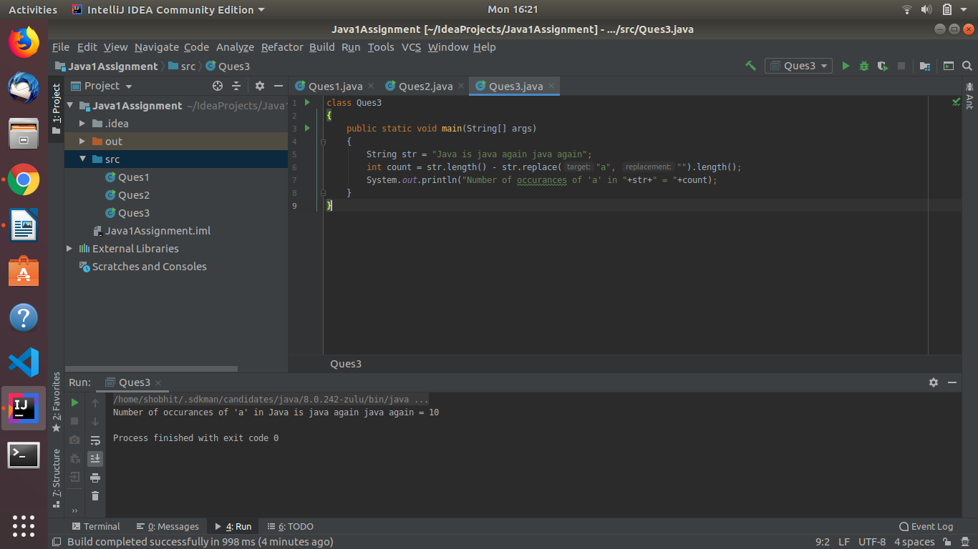

4.
public class Ques4 {
public static void main(String[] args) {
String s = "India is my country 100%";
int upperCount = 0;
int lowerCount = 0;
int digitCount = 0;
int specialCount = 0;
float upperPercent, lowerPercent, digitPercent, specialPercent;
for (int i = 0; i < s.length(); i++) {
char a = s.charAt(i);
if (Character.isUpperCase(a)) {
upperCount++;
} else if (Character.isLowerCase(a)) {
lowerCount++;
} else if (Character.isDigit(a)) {
digitCount++;
} else
specialCount++;
}
upperPercent=(upperCount*100)/(s.length());
lowerPercent=(lowerCount*100)/(s.length());
digitPercent=(digitCount*100)/(s.length());
specialPercent=(specialCount*100)/(s.length());
System.out.println(“Count of uppercase characters is: “+upperCount+”Percentage of uppercase
Characters is”+upperPercent);
System.out.println(“Count of lowercase characters is: “+lowerCount+”Percentage of lowercase
Characters is”+lowerPercent);
System.out.println(“Count of digit characters is: “+digitCount+”Percentage of digit
Characters is”+digitPercent);
System.out.println(“Count of special characters is: “+specialCount+”Percentage of special
Characters is”+specialPercent);
}
}

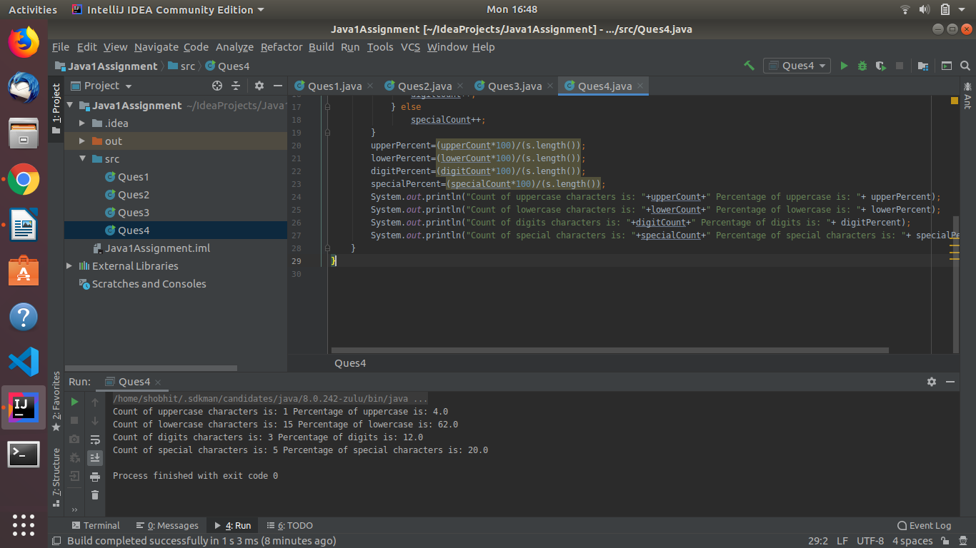

5.
public class Ques5 {
public static void main(String[] args) {
int[] arr = new int[]{1, 2, 3, 4, 5, 6, 7, 8};
int[] arr1 = new int[]{3, 4, 5, 6};
int ctr = 0;
for (int i = 0; i < arr.length; i++) {
for (int j = 0; j < arr1.length; j++) {
if (arr[i] == arr1[j]) {
ctr++;
System.out.println(arr[i]);
}
}
}
System.out.println("Total common elements are: " + ctr);
}
}

6.
public class Ques6 {
public static void main(String[] args) {
int arr[]=new int[]{1,2,3,1,4,2,3,5,6,5,6};
int sum = 0;
for (int i=0;i<arr.length;i++){
sum = sum ^ arr[i];
}
System.out.println(sum);
}
}

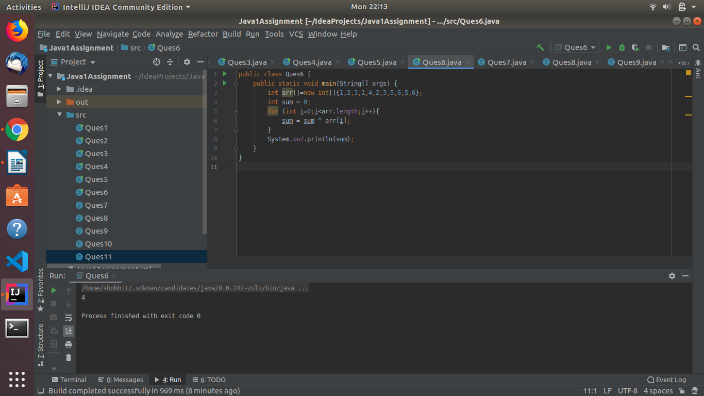

7.
a. Static block

public class Ques7 {
static int age;
static String fName;
static String lName;

static {
age = 24;
fName = "Shobhit";
lName = "Bisaria";
}

public static void main(String[] args) {
System.out.println("Age is: "+age);
System.out.println("First name is: "+fName);
System.out.println("Last name is: "+lName);
}
}
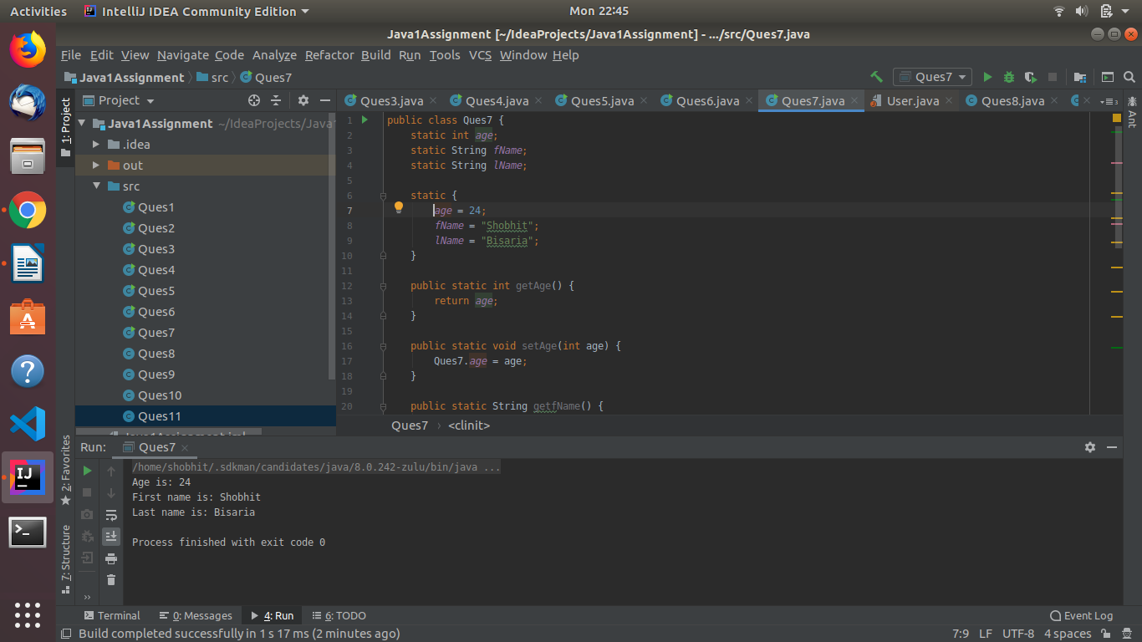

b.
public class Ques7 {
static int age;
static String fName;
static String lName;

static {
age = 24;
fName = "Shobhit";
lName = "Bisaria";
}
public static void print(int a, String fn, String ln){
age = a;
fName = fn;
lName = ln;
System.out.println("Age: "+age + " First name: "+fName+" Last name: "+lName);
}
public static void main(String[] args) {
System.out.println("Age is: "+age);
System.out.println("First name is: "+fName);
System.out.println("Last name is: "+lName);
Ques7.print(24, "Shobhit", "Bisaria");
}
}
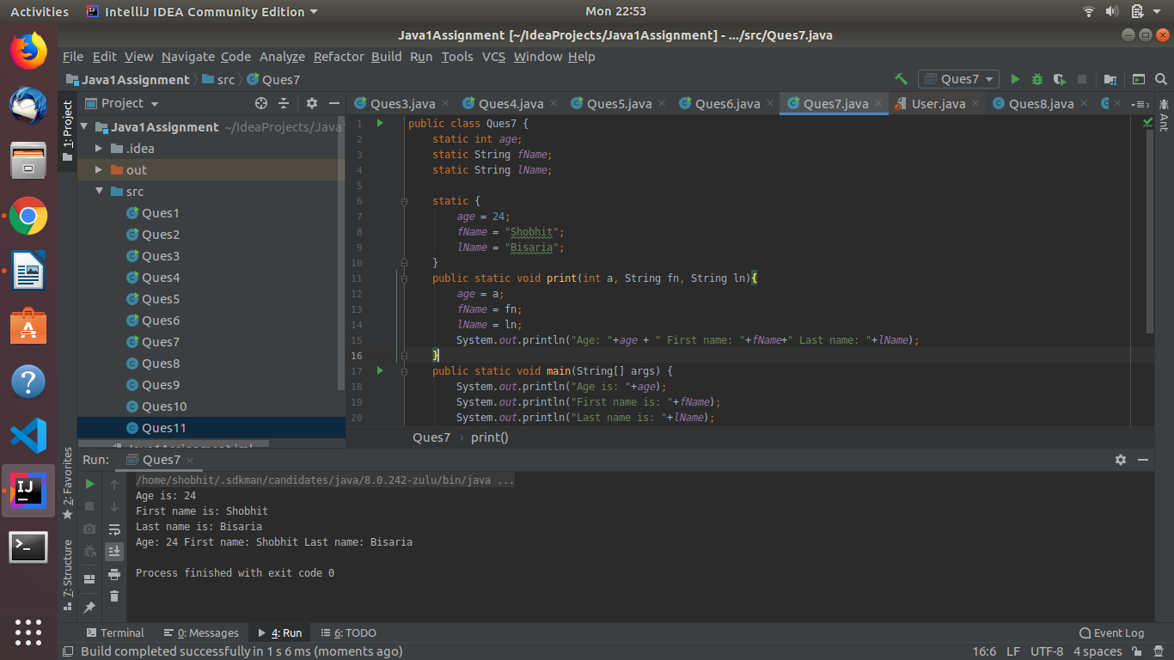
c.
public class Ques7 {
static int age = 23;
static String fName = "S";
static String lName = "B";

public static void main(String[] args) {
System.out.println(Ques7.age);
System.out.println(Ques7.fName);
System.out.println(Ques7.lName);

}
}
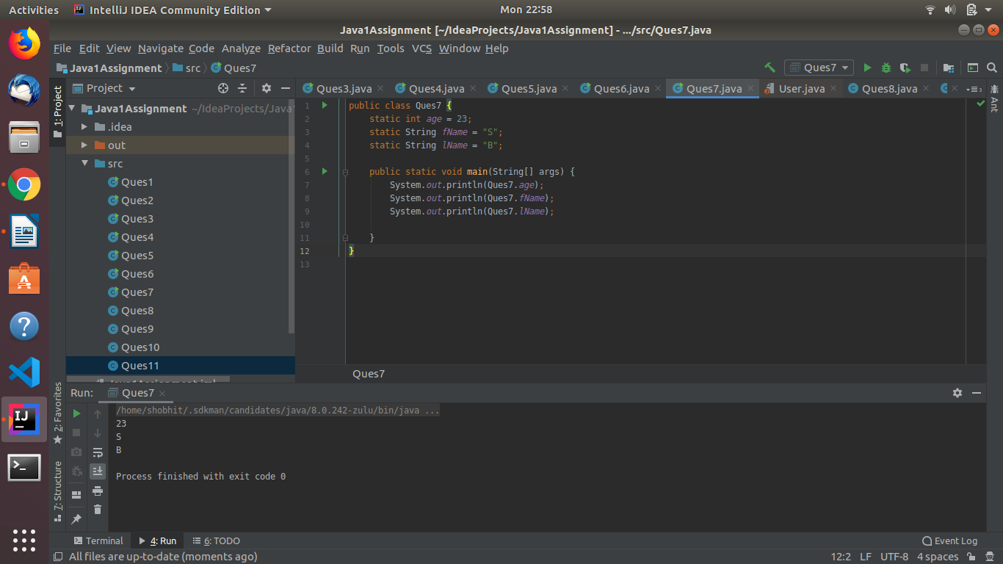

8.
public class Ques8 {
public static void main(String[] args) {
StringBuffer str = new StringBuffer("Java is a Programming language");
System.out.println("Original string: "+str);
str.reverse();
System.out.println("Reversed string: " + str);
str.delete(4, 10);
System.out.println("Resulting string after deletion: " + str);
}
}
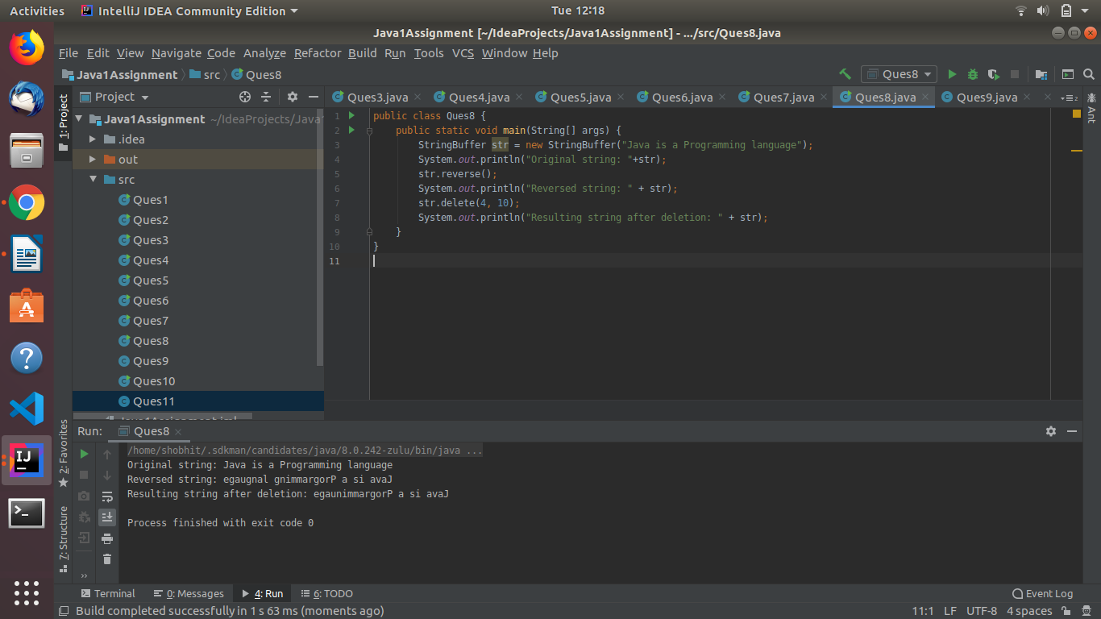

9.
enum House {
House1(25000), House2(30000), House3(50000), House4(15000), House5(20000);
private int price;
House(int p) {
price = p;
}
int getPrice() {
return price;
}
}
public class Ques9{
public static void main(String args[]){
System.out.println("All house prices:");
for (House h : House.values()) System.out.println(
h + " costs " + h.getPrice() + " Rupees");
}
}
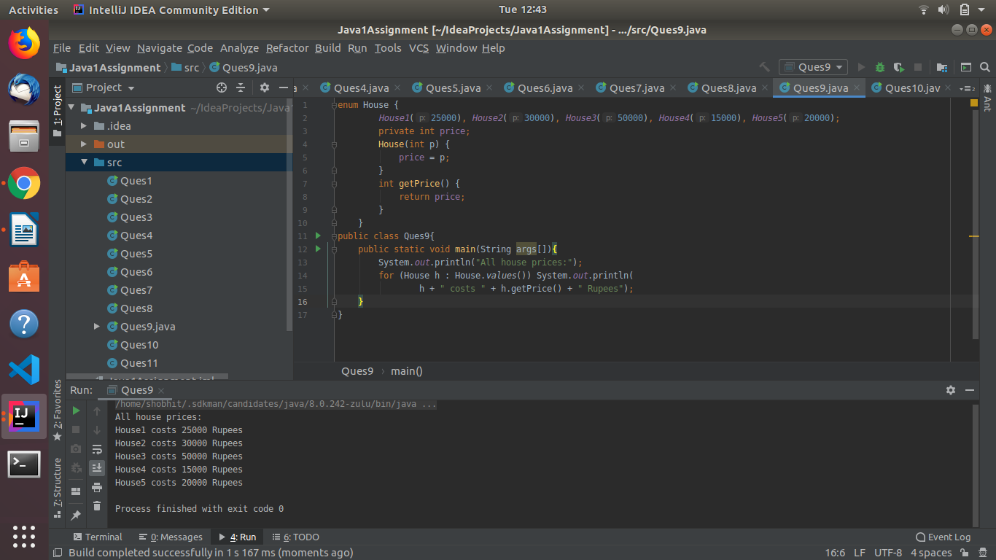

10.
public class Ques10 {
public static void main(String[] args) {
Ques10 obj = new Ques10();
int a = 5;
int b = 6;
double c = 5.5;
double d = 6.5;
float x = 2.4f;
float y = 5.4f;
String s1 = "Java";
String s2 = "is";
String s3 = "Good";
obj.operations(a, b);
obj.operations(c,d);
obj.operations(x,y);
obj.operations(s1,s2);
obj.operations(s1,s2,s3);
}

public void operations(int a, int b) {
int sum = a + b;
System.out.println(sum);
}

public void operations(double c, double d) {
double sum = c + d;
System.out.println(sum);
}

public void operations(float x, float y) {
float pro = x * y;
System.out.println(pro);
}

public void operations(String p, String q) {
String con = p + q;
System.out.println(con);
}
public void operations(String s1, String s2, String s3){
String con = s1 + s2 + s3;
System.out.println(con);
}
}
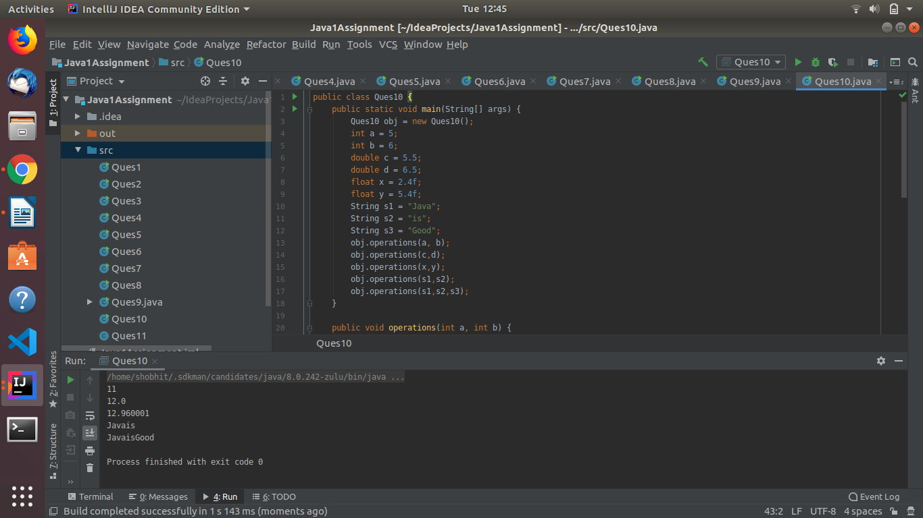

11.
public class Bank {
double rateOfInterest;
Bank(){}
Bank(double r){
rateOfInterest = r;
}
public void getDetails(){
System.out.println(rateOfInterest);
}
}
class SBI extends Bank{
double rateOfInterest;
SBI(double r){
rateOfInterest = r;
}
public void getDetails(){
System.out.println("SBI interest rate: "+rateOfInterest);
}
}
class BOI extends Bank{
double rateOfInterest;
BOI(double r){
rateOfInterest = r;
}
public void getDetails(){
System.out.println("BOI interest rate: "+rateOfInterest);
}
}
class ICICI extends Bank{
double rateOfInterest;
ICICI(double r){
rateOfInterest = r;
}
public void getDetails(){
System.out.println("ICICI interest rate: "+rateOfInterest);
}
}
class Main{
public static void main(String[] args) {
Bank b = new Bank(0.0);
Bank b1 = new SBI(10.2);
Bank b2 = new BOI(11.1);
Bank b3 = new ICICI(10.4);
b.getDetails();
b1.getDetails();
b2.getDetails();
b3.getDetails();
}
}
